## Darshan Nikam Date: 22/02/2024

**Task: Create the new IAM User then create a User Group, attach a custom policy to that group,**

**And add a new user to that Group.**

**Step 1) Login to your AWS Console, and go to IAM Service.**

**Step 2) Click on the User Button of the Dashboard Menu of the IAM.**

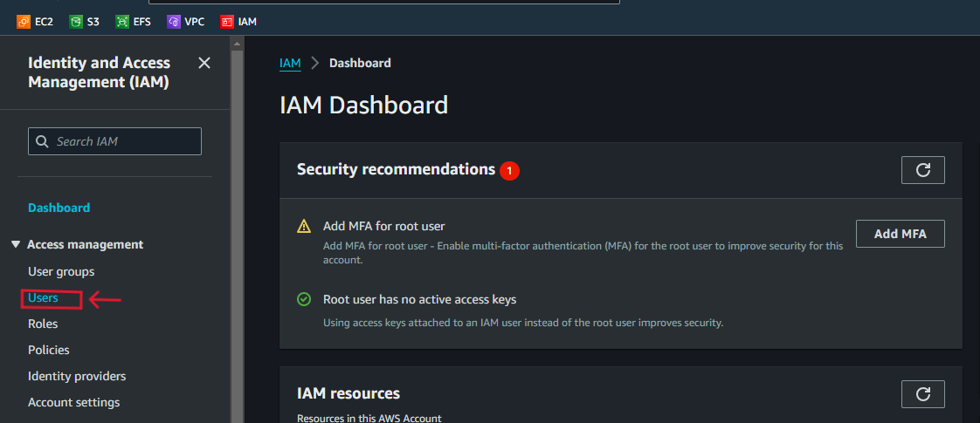

**Step 3) Click on the Create User Button, and specify the user details then click on the Next Button**

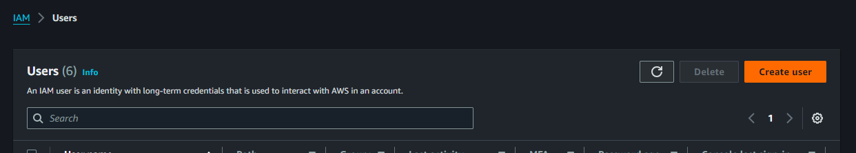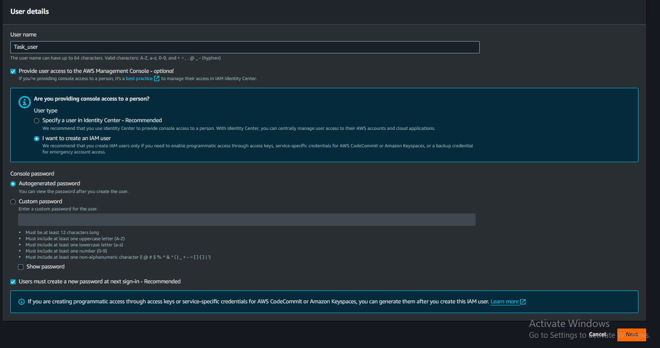

**The user Permission Set page will be open.**

**Step 4) Click on the Create Group Button, Create user group pop-up will open, then simply give the Group name and click on the Create Policy button. A new tab of custom policy will open.**

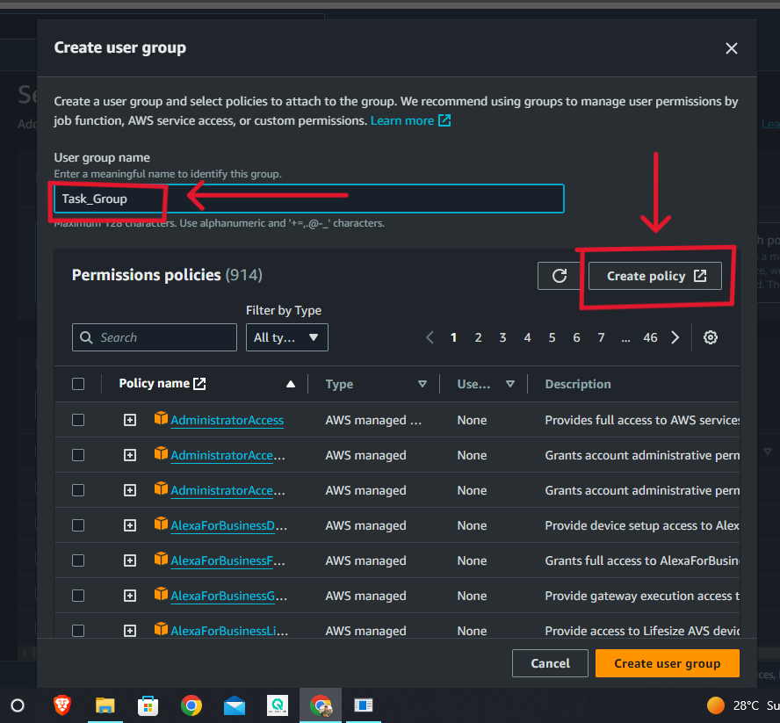

**Step 5) Select the service that permission you want to give and click on the Next Button, then Set actions (permissions), there are many micro permissions available you can set as your requirement, and simply click on the Next Button.**

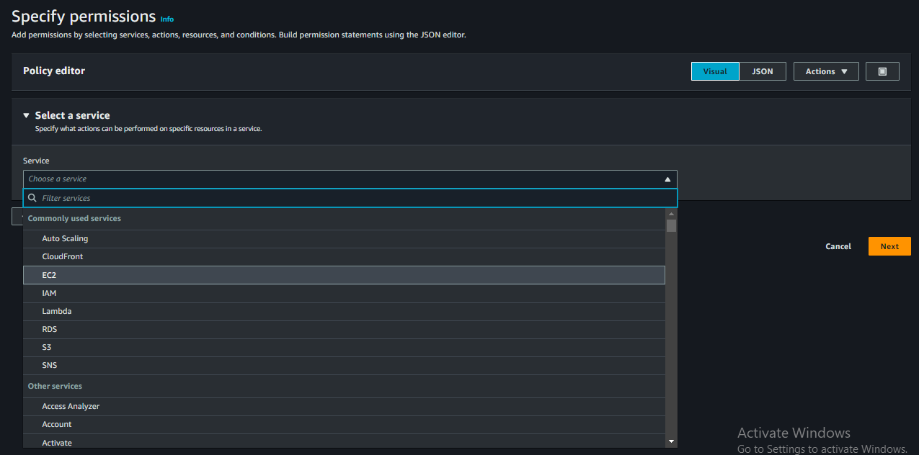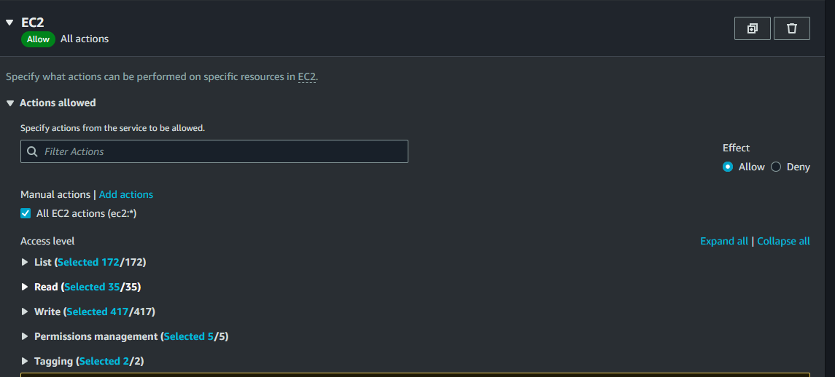

**Step 6) The Policy Review and Create page will open, give the policy name, check the permission you defined in the Policy, add a tag, and click on the Create Policy Button.**

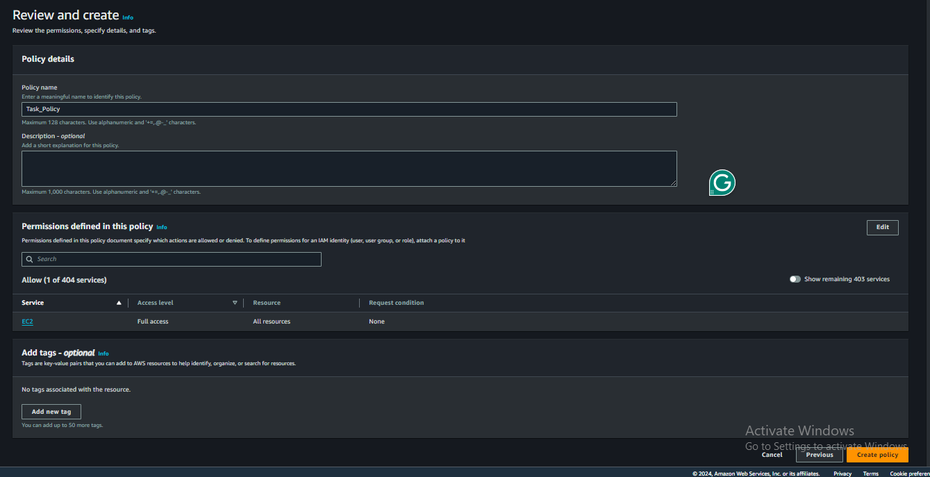

**Now Your Custom policy is created, go to the previous page (Create User Group tab).**

**Step 7) Click on the filter option of Policies then select the custom managed option, and click on the refresh symbol button. Now newly created policy appears in the list, select the policy, and click on Create User group.**

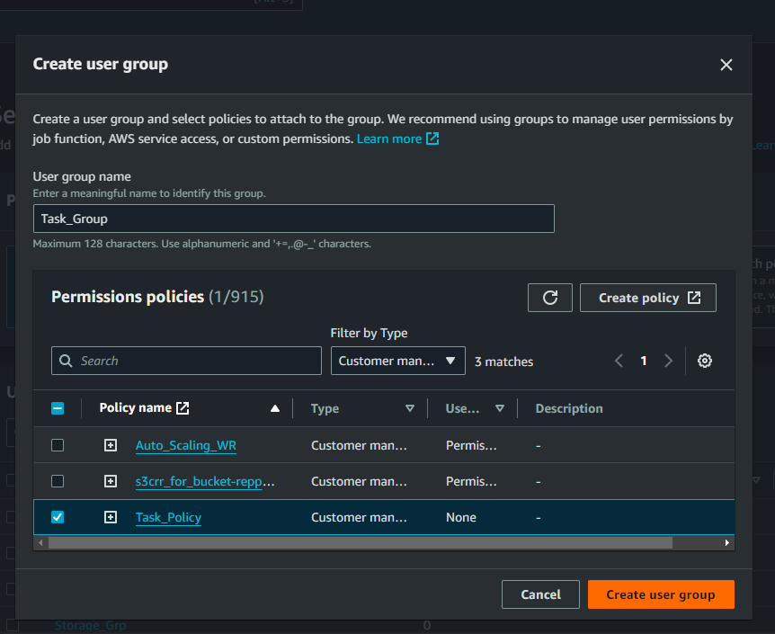

**Now your User group is created.**

**Step 8) Select the group that you recently created, and click on the Next Button.**

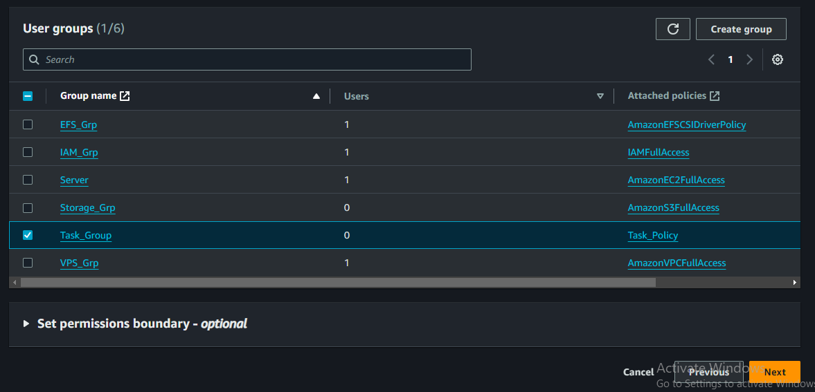

**Step 9) The Review and Create page will open, check the details, and click on the Create user button. You will receive a notification of the user created successfully, click on view user.**

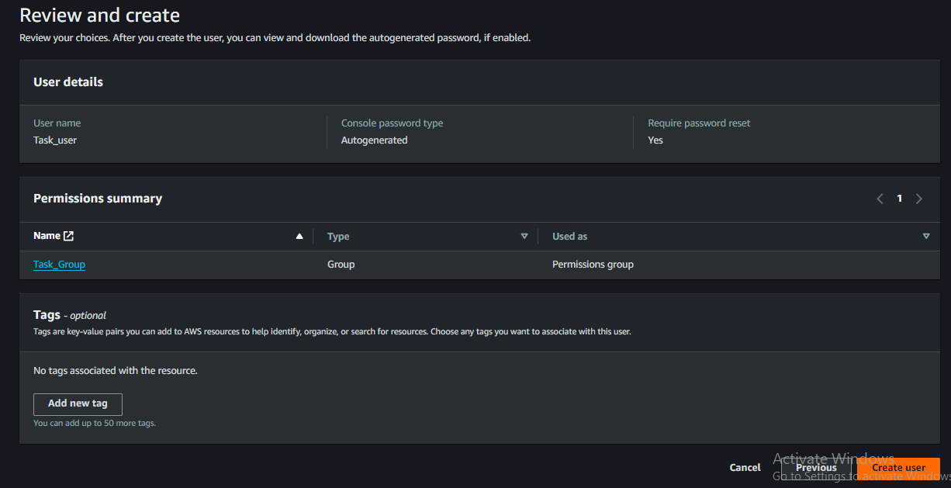

**Now you will see a new user has been created in a particular group that has a custom policy assigned by you.**